**8086 MICROPROCESSOR**

Author: Bharat Acharya

Sem IV – Electronics Mumbai 2018



|  |
| --- |
|  |
| **INTRODUCTION TO MICROPROCESSORS** |
| **WWW.BHARATACHARYAEDUCATION.COM** |

**BHARAT ACHARYA EDUCATION**

Videos | Books | Classroom Coaching

E: bharatsir@hotmail.com

M: 9820408217



# INTRODUCTION | BASIC ORGANIZATION OF A COMPUTER

A computer system, as we know it, consists of various components.

They can be broadly classified into three sections:

The Processor, Memory and I/O.

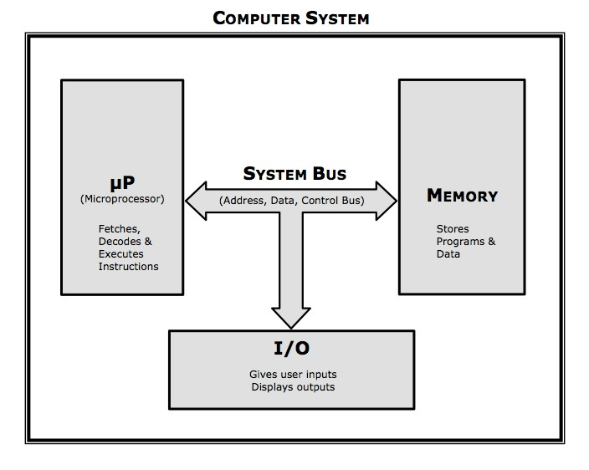

**8086 MICROPROCESSOR**

Author: Bharat Acharya

Sem IV – Electronics Mumbai 2018



# THE PROCESSOR – “μP”

The heart of the computer is its μP (Microprocessor).

Current generation computers use processors like Intel Core i3, i5 or i7 and so on. They have come a long way from the initial processors that you are about to learn E.g.: 8085, 8086 etc.

Back in the day (1940s), when micro-electronics was not invented, processors looked very different and were certainly not “micro” in appearance. They were created using huge arrays of physical switches which were operated manually and often occupied large rooms.

In the following decades, with the invention of micro-electronics, scientists managed to embed thousands of microscopic switches (transistors) inside a small chip, and called it a “**Micro-processor**”.

Over the years, microprocessors grew in strength.

From housing a few thousand transistors (8085) to containing more than a billion transistors (Core i7), the computational power has been increasing exponentially. Having said that, some of the basics still remain the same.

To put it simply, **the main function of a μP is to Fetch, Decode and Execute instructions.**



Instructions are a part of programs. Programs are stored in the memory.

Firstly, μP fetches an instruction from the memory.

It then decodes the instruction. This means, it “understands” the binary pattern of the instruction, also called its opcode. Every instruction when stored in the memory is in its unique binary form, which indicates the operation to be performed. This is called its opcode. Upon decoding the opcode, μP understands the operation to be performed and hence “executes” the instruction. This entire process is called an **“Instruction cycle”**.



Now the process is repeated for the next instruction.

Like this, one by one, all instructions of a program are executed.

Of course by advanced concepts like **pipelining**, **multitasking**, **multiprocessing** etc., this procedure has become very advanced and efficient today. You will get to learn all of them, in the due course of this ever intriguing subject.

We begin learning with basic processors like **8085** or **8086**, but make no mistake, non of this is “outdated”. Yes, your mobile phone or your computer today uses the most advanced cutting edge processors (**A11 Bionic** et.al ), but to run a **traffic light** or **TV remote** control you don’t need a core i7 now, do you? And these are used by the millions across the world. They simply use processors of the same grade as an 8085 or an 8086, with different product numbers as they are made by various manufacturers.

**BHARAT ACHARYA EDUCATION**

Videos | Books | Classroom Coaching

E: bharatsir@hotmail.com

M: 9820408217



# MEMORY

Memory is used to store information.

It stores two kinds of information… programs and data.

For example:

MS Word is a program, and the word documents are its data.

Video player is a program, and the videos are its data.

WhatsApp is a program, and the messages are its data, and so on.

All programs and data are stored in the memory, in digitized form, where every information is represented in 1s and 0s called binary digits or simply bits.

There are various forms of memory devices.

The main memory also called primary memory consists of Ram and ROM.

Other memory devices like Hard disk, Floppy, CD/ DVD etc. are secondary storage devices.

Additionally there is also a high speed memory called Cache composed of SRAM.

For the majority portion of this book, you are dealing with the initial processors like 8086. It will be in your best interest to think of Primary Memory only, whenever we speak of memory. That is because, secondary memory and high speed memories were implemented much later in the evolution of processors as the demand for mass storage and high speed performance started increasing. So, from now on in this book, unless specified otherwise, **the word memory refers to primary memory that is RAM and ROM.**



The memory is a series of locations.



Each location is identified by its own unique address.

Every location contains 1 Byte (8 bits) of data. There is a very good reason for this, and you will learn it when we discuss the topic of memory banking in 8086.



# I/O DEVICES

I/O devices are used to enter programs and data as inputs and display or print the results as outputs. We are all familiar with devices such as the keyboard, mouse, printer, monitor etc. Every form of computer system has a set of I/O devices for human interaction. A device like a touch screen performs dual functions of both input and output.

The μP, Memory and I/O are all connected to each other using the System Bus.